**How to Use Template**

**Hatsune Miku Blogger Template**

Edit Meta Tag Author

1. Go to Blogger.com log in your account blog
2. Your Blog > Template > Edit Html
3. Find (CTRL + F)

<meta content=**'XXXXXX'** name='Author'/>

……..

Change **XXXXXX** with your ID Google Profile

Edit Meta Tag Admin Facebook

Find Meta tag like this

<meta content=**'XXXXXX'** name='twitter:site'/>

<meta content=**'XXXXXX'** name='twitter:creator'/>

Replace with your id/username twitter

Edit Meta Tag Author Twitter

Find Meta tag like this

<meta content=**'XXXXXX'** name='twitter:site'/>

<meta content=**'XXXXXX'** name='twitter:creator'/>

Replace with your id/username twitter

TIPS SEO

1. Find and Delete this below Html

<b:include name='quickedit'/>

2. add ALT and Title in your Images

<imgsrc=**’exampleurlimage’** alt=’post title’ title=’post title’ />

Add Picture in Header [Important]

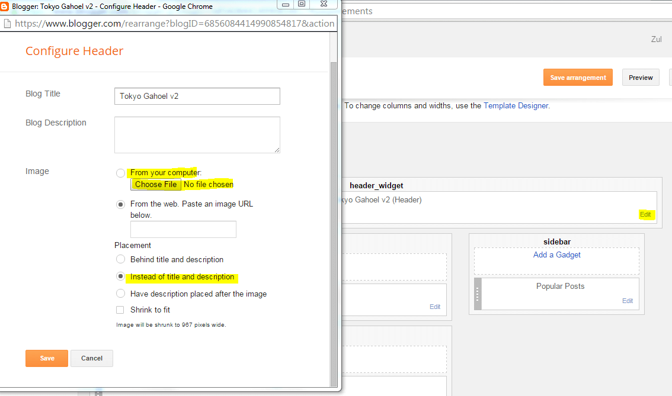

TIPS SEO in Widget Title

1. Find this below (in widget)

**<h2><data:title/></h2>**

And replace with this code

**<h3><data:title/></h3>**

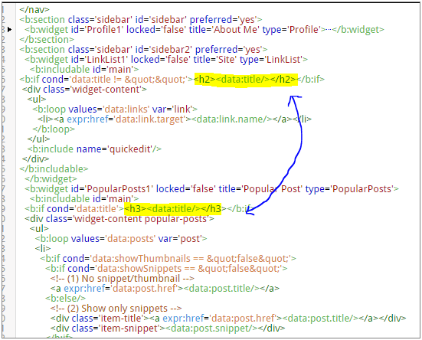

Disable Custom Mobile

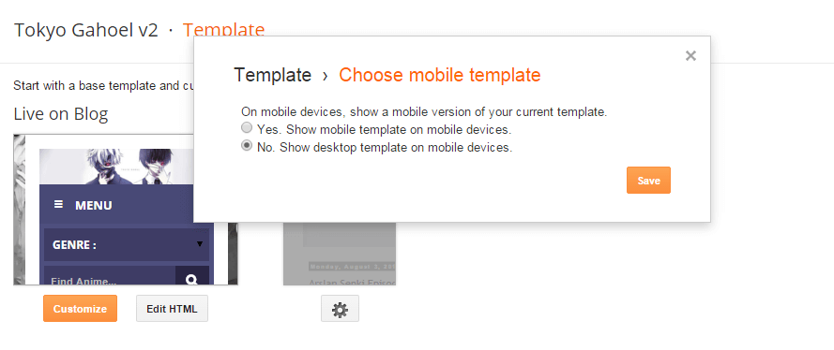

Menu Dropdown

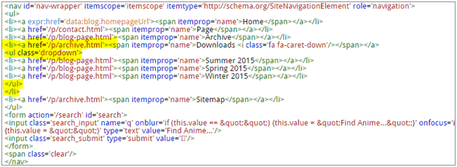

<ul> and </ul> This a dropdown code

Add Icon in Widget

1. Go to Blogger.com log in your account blog
2. Your Blog > Template > Edit Html
3. Find (CTRL + F) <b:if cond='data:title != &quot;&quot;'>

Example :

<b:if cond='data:title != &quot;&quot;'>

<h2 class='title'><data:title/></h2>

</b:if>

1. Then add icon <i class=’glyphicon glyphicon-heart’/> <- example

<b:if cond='data:title != &quot;&quot;'>

<h2 class='title'><i class=’glyphicon glyphicon-heart’/><data:title/></h2>

</b:if>

Get Icon from [Here!!](http://getbootstrap.com/components/#glyphicons)

Thanks for

* Google Translate
* Konachan for Header Image
* DTE for Tips & Trick Blogger
* Bootstrap for Framework
* Kara-tsuru for dummy post
* Etc ._.